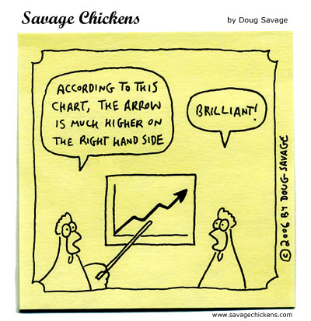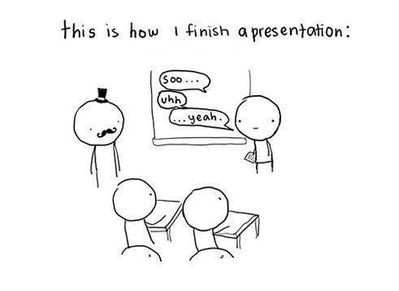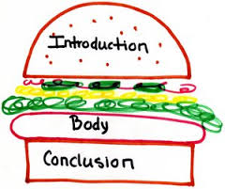

PRESENTATION TIPS:

1. Have an introduction – Tell the class what the point/purpose of your presentation. Possibly what are the outcomes and what are they going to learn.
2. Have a conclusion – sum up what the key points were again, the purpose/main idea. Do not say, ‘the end’, or ‘um, yeah, that’s it”
3. Eye contact – glace at your notes but make eye contact and connect with your audience. Don’t simply read your whole presentation. **Talk don’t read**.
4. Add interesting images or comics to your presentations – become more interactive – ask audience about image.
5. Smile
6. Be animated – walk around and move, do not sit or have hands in pockets, use hand gestures, use your voice intonations – not monotone.
7. Speak clearly – not too slow or quick, speak confidently – you are the expert on your researched topic. Use your own words.
8. Use silence/wait time/pauses to emphasize points
9. PRACTISE before you present to the class

TASK:

1. On a scale of 1 – 10 rate yourself on each of the above presentation tips. Explain why you have given yourself that mark.
2. Identify 3 things you can do to improve your next presentation.

Print, and Submit to teacher.



