Website Design

Defining a purpose: Why are you creating this site? Do you want to sell something? Are you distributing information/ creating awareness for an organization/event? What do you want people to do once they have looked at your site?
Determine Your Audience: Who are you targeting with your site (age, gender, hobbies, where they live)? What are they like (characteristics/preferences). Why will they visit your site and not others, what are their expectations from their visit?
Decide on Your Content: what kind of information and features does your audience want to see in your shite? Create a word web with the purpose in the centre – this can be used as a guide for the content text and images that you need to create.
Decide on the Organization of you Website: Organization is called the navigation structure. Most websites use a hierarchical arrangement (top level, second level etc.). The top level would be your home page or the purpose and second level would be important categories, and third level sub categories.

The most important aspect of website design is usability – how easy it is to use the site. A breadcrumb trail is a technique that helps users keep track of their current location on the site.
Organization of the Interface: Generally place the top level navigation at the top of the page and secondary navigation along the left side or vice versa.
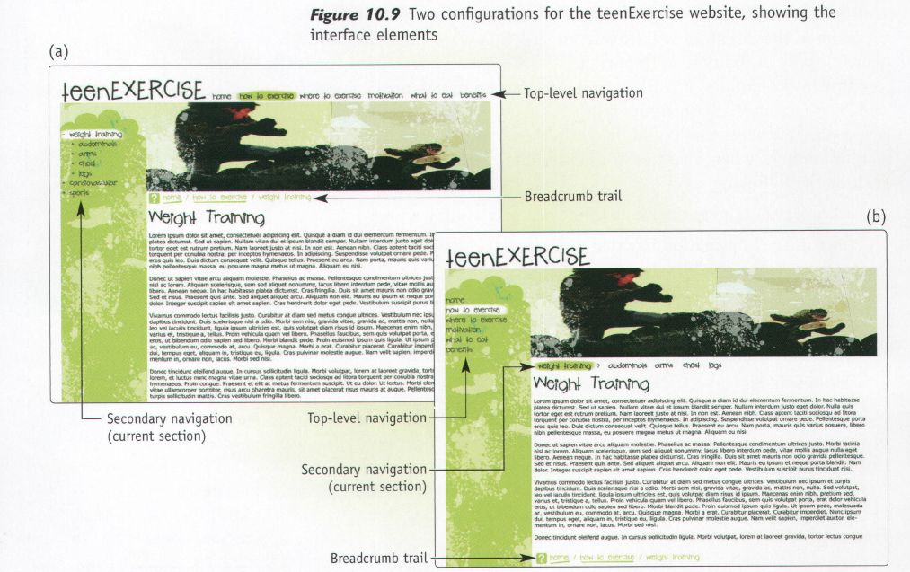

Principals of Good Graphic Design

Balance: Symmetrical Balance Asymmetrical Balance Radial Balance

Contrast
Created by making two related graphic elements different. The more different they are the greater the visual interest. It can also emphasize the most important parts of your message. Constrast can be created through:
- Size Variances – place large and small object near each other to show relative importance.
- Type choices – choose different fonts for headings and text
- Colour selection – place a light element on a dark background, or vice versa, to bring attention to that element.

Consistency
It is important to have recognizable graphic elements for a company logo or brand. For example; typefaces, text alignment, colours and graphic images (logos).
Creating Consistency:
- Margins and page layout – keep it the same
- Fonts – two fonts are more than enough and should be used consistently acrocess all publications for a company
- Navigation (for websites)- keep in the same location on every web page.
- Colour – limit to 2-3 colours. Taking your lead from those that appear in your logo.

Case Study

